From: https://medium.com/predict/flow-batteries-are-here-and-they-will-change-everything-66fa1eb3bbc7
Stories for Frederick N. Chase
Date: June 28, 2022
@fchase·Member
7 min read


Rendering of Lockheed Martin redox flow battery at Fort Carson — Lockheed Martin

Flow Batteries Are Here And They Will Change Everything

A new technology is taking battery sustainability to a whole new level.
As the world turns its back on fossil fuels, battery technology is becoming increasingly important. Unfortunately, our current batteries are far from ideal, particularly lithium-ion batteries. They have short lifespans, cost a bomb, have a substantial environmental impact, habitually catch on fire, and are difficult to recycle. But this is all set to change, as a new revolutionary battery is ready to take over. Welcome to the wonderful world of flow batteries.
Usually, when I talk about new battery technology, they tend to be concepts currently being developed in a lab, where they won’t see the light of day for years. But flow batteries are already a reality. Fort Carson, a US military base, has contracted Lockheed Martin to build a 10 MWh redox flow battery to store its solar farm’s energy. Why has this military base opted for this technology? Well, it has a nearly-infinite life cycle, almost no degradation, huge safety margins, is nearly 100% recyclable, is incredibly eco-friendly, and all while being astonishingly cheap.
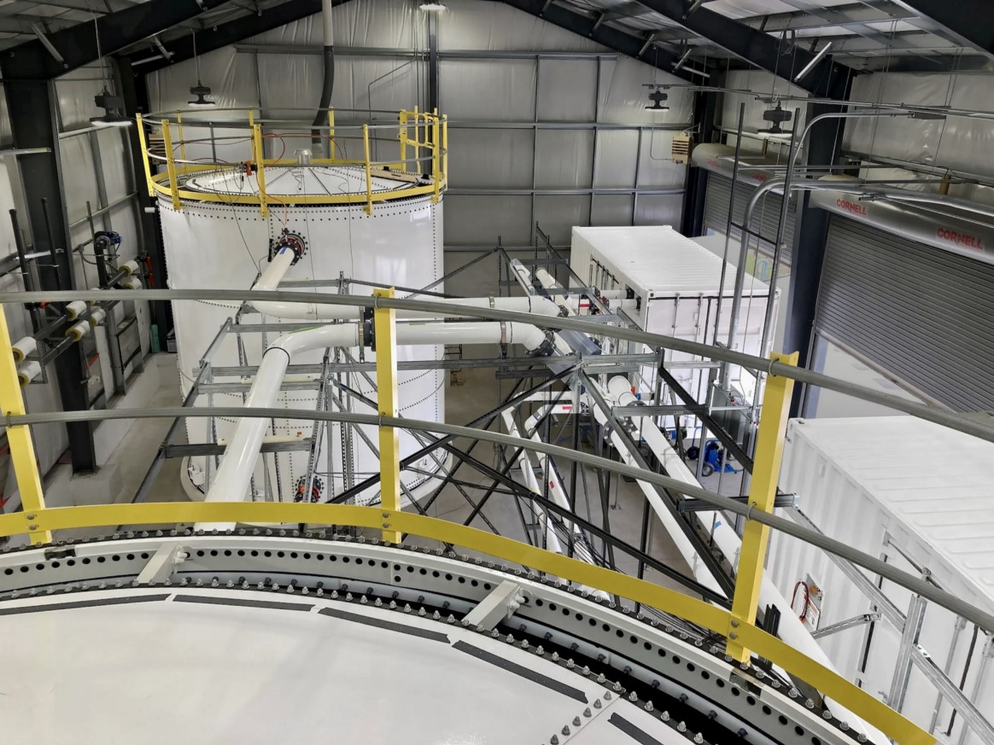
Lockheed Martin’s redox flow battery “Gridstar” — Lockheed Martin
The way that redox flow batteries achieve these incredible characteristics is down to their remarkably simple design.
Lithium-ion batteries store charge by moving lithium-ions from one side of the battery to the other. But the parts that hold this charge, the cathode and anode, execute the energy storage and power delivery. This dual-purpose means that we need complex chemistry in order to optimise the batteries. This complexity is why they are expensive and have such a huge carbon footprint and ecological impact, due to extensive mining. Moreover, this dual-purpose also leaves these batteries vulnerable to dendrites, the deposits that cause the battery to lose capacity over time. There is also the fact that lithium-ion batteries have an annoying tendency to catch fire, creating a new need for extensive safety measures to be put in place.
But redox flow batteries solve this by separating the parts holding the charge and the parts delivering the power. These batteries are made up of two tanks of electrolytic liquid with a “separator” in between and an electrode in each tank. When a current is passed between the electrodes, one electrolyte loses an electron (in a process known as oxidation) and gives it to the other (known as reduction). This means that one liquid is positive and one is negative, which provides an electrical potential, or voltage, between the two electrodes that can power a circuit.
To make this process more efficient, the tanks are made larger, and the electrolytic liquid is pumped into a ‘cell stack’ which holds the separator and electrodes. This creates a flow over the electrodes, which ensures the voltage stays constant and allows for a massive capacity, given the increase in electrolytic liquid.
So if you want a redox flow battery to hold more power, you can create larger tanks. Or, if you want it to deliver more power, you can create larger cell stacks. This flexibility means that it can effectively be tailored to its purpose, allowing it to be more compact and more efficient in order to best suit whatever job it does.
Most redox flow batteries use a vanadium electrolytic liquid (known as a Vanadium Flow Battery or VFB). As long as this liquid remains pure, it can undergo millions of life cycles without losing any of its capacity. This is because the reduction and oxidation process (collectively known as redox) doesn’t degrade the liquid or cause damaging deposits. This is in stark contrast to lithium-ion batteries that can only do a few thousand charges before losing substantial capacity.

Vanadiumite, a relatively common vanadium dense mineral — WikiCC
Furthermore, vanadium is a readily accessible element in many different easy-to-find minerals. The rest of the battery is made up of equally accessible materials, making it easy to assemble and recycle, in comparison to lithium-ion batteries, which need metals like cobalt and manganese to function. Not only is the mining of these metals very environmentally damaging, as it causes toxic heavy metals to leach from mines and trigger extensive habitat loss. But refining these metals and assembling them into a battery also requires a lot of energy and planet wrecking carbon emissions. These metals are also highly toxic, making recycling and end-of-life disposal tricky. Overall, this means that redox flow batteries are much better for the environment.
This simplicity, combined with easy access to materials and easy assembly, makes redox flow batteries incredibly cheap. Right now, lithium-ion batteries cost, on average, $132 per kWh. This means that if Fort Carson were to use a lithium-ion battery for its base, it would cost a massive $1.32 million. But redox flow batteries can go as low as $25 per kWh without compromising performance, making the Fort Carson battery only a quarter of a million dollars.
But this cheapness isn’t just for one-off purchases. Lithium-ion batteries only last about 10 to 20 years as grid batteries. After that, they must be replaced or expanded to compensate for the drop in capacity. Meanwhile, the redox flow battery should last for well over a century with minimal maintenance, making flow batteries exponentially cheaper in the long run.

Photo by Flavio Gasperini on Unsplash
Finally, there is the matter of safety. Lithium-ion batteries can ignite if overloaded or overheated. This has caused massive fires in everything from phones to Teslas and, yes, even solar farm batteries. Do you think a military base would want to install a giant bomb next door that, if the enemy were to hit it, would just blow up? Probably not. But a redox flow battery can’t catch fire. Nothing in it is flammable, making it far safer. This might be why Fort Carson is so interested in the technology, given it makes their renewable energy far less vulnerable to enemies. However, in the rest of the world, this could allow flow batteries to be located closer to civilians without any safety fears, which could also increase efficiency within the electricity grid by reducing distances between grid batteries and consumers.
So, let’s quickly recap. This incredible new battery is cheaper, more sustainable, longer-lasting, and safer than anything else. So what’s the catch?
Well, it doesn’t have the best efficiency. Lithium-ion batteries are nearly 100% efficient. This means that if you charge one up with 1 Whr of power, you will receive 0.99999 WHr back. But redox flow batteries are only up to 85% efficient. This means that a solar farm with a redox flow battery would need to be 15% larger than one with a lithium-ion battery in order to have the same output power.

Flow battery solar farms need to be bigger — Photo by American Public Power Association on Unsplash
Now, if you are a regular reader of mine, you will know my thoughts on sprawling solar farms. They can cause massive habitat loss and, in turn, damage vital local ecosystems. Furthermore, the more solar panels you need, the higher the carbon footprint of the solar farm! So surely this means that redox flow batteries would make solar power worse for the environment, right?
Well, firstly, recent studies show that if locations and designs are chosen carefully, solar farms can act as nature reserves and bolster biodiversity. So, solar farms’ being 15% bigger isn’t an issue if appropriately designed. Furthermore, the carbon emissions of producing the extra panels should be more than offset by the carbon savings of the flow battery. The same is true for cost. Solar panels aren’t that expensive anymore, so even though you need 15% more of them, that price increase should be less than the cost savings of the flow battery.
Solar power is already the cheapest and one of the lowest carbon forms of energy we have. So redox flow batteries will take solar to another level of affordability and sustainability, which is fantastic because that is what we need to save the world from a climate disaster. We need every country to adopt highly sustainable energy as quickly as possible. With this technology, we can do that without bankrupting ourselves.
So that is how and why redox flow batteries are set to take over the world. With advances like this, it makes you wonder why we are even bothering with fusion energy, as we already have the technology that could turn us into a carbon-neutral, planet-friendly, utopian society. We just need to start using it.

